# Exercise 1: Basic HTML5 Structure

<!DOCTYPE html>

<html lang="en">

<head>

<meta charset="UTF-8">

<meta name="viewport" content="width=device-width, initial-scale=1.0">

<title>MY First HTML Page</title>

</head>

<body>

<h1>DARUR VINAY</h1>

<p>I Love Travelling, Exploring New things and play Cricket.</p>

<hr>

<br>

</body>

</html>

**Output:**



# Exercise 2: Use of Lists and Links

<!DOCTYPE html>

<html lang="en">

<head>

<meta charset="UTF-8">

<meta name="viewport" content="width=device-width, initial-scale=1.0">

<title>MY First HTML Page</title>

</head>

<body>

<h2>My Favorite Fruits:-</h2>

<ul>

<li>Mango</li>

<li>Orange</li>

<li>Pineapple</li>

</ul>

<h2>Top 3 Movies:-</h2>

<ol>

<li>HIT</li>

<li>Officer On Duty</li>

<li>MAX</li>

</ol>

<p>

Visit My Favorite Website:

<a href="https://www.iplt20.com/" target="_blank">IPL</a>

</p>

</body>

</html>

**Output:**

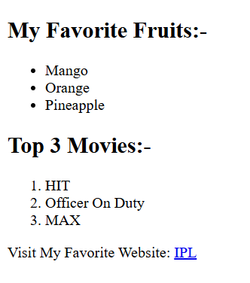

**Exercise 3: Adding Images and Tables**

# <!DOCTYPE html>

# <html lang="en">

# <head>

# <meta charset="UTF-8">

# <meta name="viewport" content="width=device-width, initial-scale=1.0">

# <title>MY First HTML Page</title>

# </head>

# <body>

# <h2>My Favorite Image</h2>

# <img src="https://images.pexels.com/photos/459225/pexels-photo-459225.jpeg?cs=srgb&dl=daylight-environment-forest-459225.jpg&fm=jpg" width="400" height="200" alt="Placeholder Image">

# <h2>Student Details</h2>

# <table border="1">

# <tr>

# <th>Student Name</th>

# <th>Age</th>

# <th>Favorite Subject</th>

# </tr>

# <tr>

# <td>Darur Vinay</td>

# <td>22</td>

# <td>Mathematics</td>

# </tr>

# <tr>

# <td>Sagar</td>

# <td>22</td>

# <td>Biology</td>

# </tr>

# <tr>

# <td>Harsha</td>

# <td>23</td>

# <td>Computer Science</td>

# </tr>

# </table>

# </body>

# </html>

# Output:

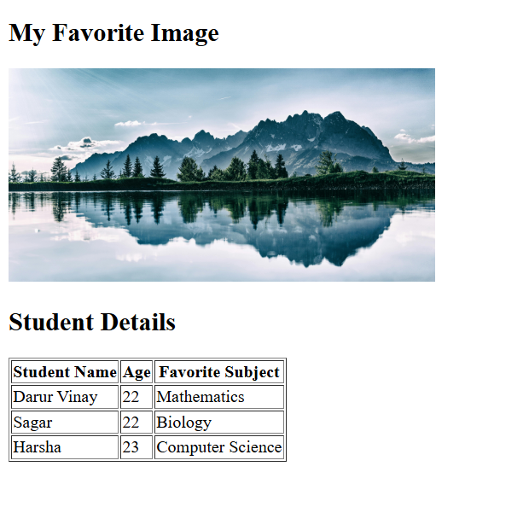

**Exercise 4: Introduction to CSS (Internal CSS)**

<!DOCTYPE html>

<html lang="en">

<head>

<meta charset="UTF-8">

<meta name="viewport" content="width=device-width, initial-scale=1.0">

<title>My First HTML Page</title>

<style> h1 {

background-color: lightblue; color: darkblue;

font-size: 30px;

}

p{

font-family: Arial; text-align: justify;

}

</style>

</head>

<body>

<h1>Darur Vinay</h1>

<p>Lorem ipsum, dolor sit amet consectetur adipisicing elit. Tempore cumque repudiandae, eius veritatis error illo, eligendi a aliquam ab enim, minus quidem necessitatibus natus? Deserunt obcaecati sed tempora architecto explicabo.</p>

</body>

</html>

**Output:**



# Exercise 5: CSS Classes and IDs

<!DOCTYPE html>

<html lang="en">

<head>

<meta charset="UTF-8">

<meta name="viewport" content="width=device-width, initial-scale=1.0">

<title>MY First HTML Page</title>

<style>

#intro {

border: 4px solid red; padding: 10px;

}

.highlight {

background-color: yellow;

}

</style>

</head>

<body>

<div id="intro">

This is the intro section with a border and padding.

</div>

<br>

<div class="highlight">

This section is highlighted with a yellow background.

</div>

</body>

</html>

**Output:**

